PRACTICAL 3

Step 1

Create a project in 3d core and name it

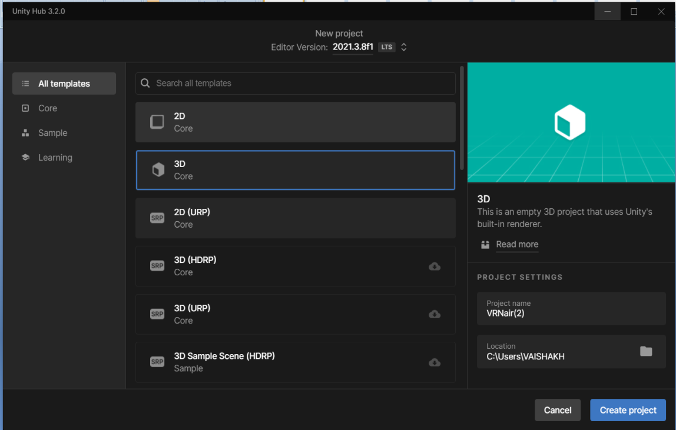

ADD A 3D PLANE TO THE PANEL

GO TO ASSETS CLICK ON CREATE AND THEN ADD MATERIAL

DRAG THE MATERIAL TO THE 3D PANEL AND CHANGE THE COLOUR TO YOUR NEED .

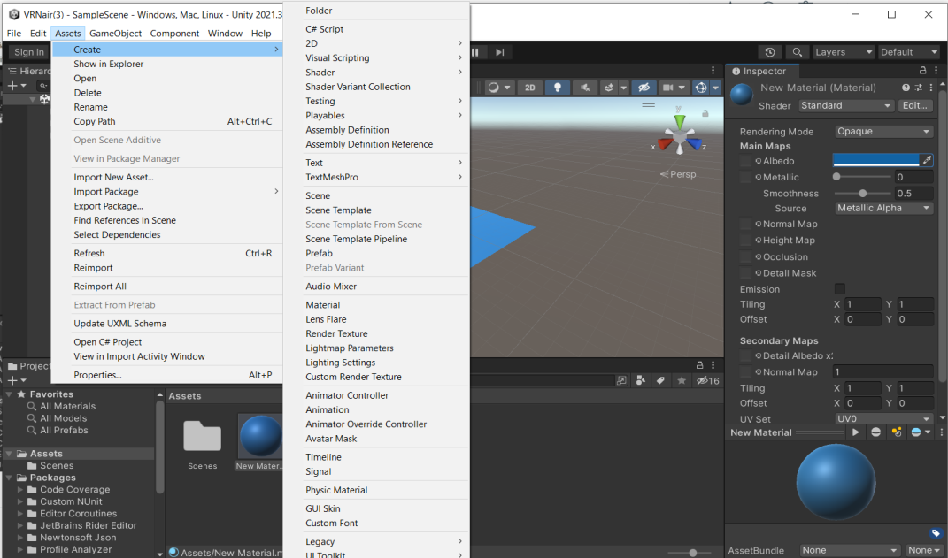

GO TO ASSETS AND IMPORT NEW ASSET

SELECT IMAGE TO YOUR LIKING

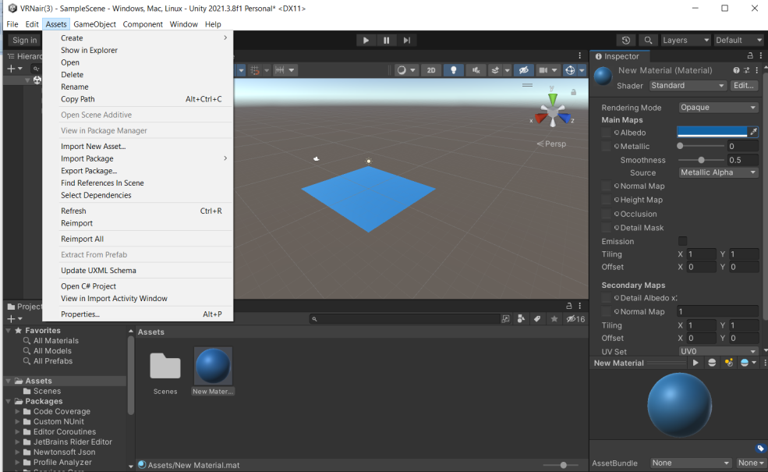

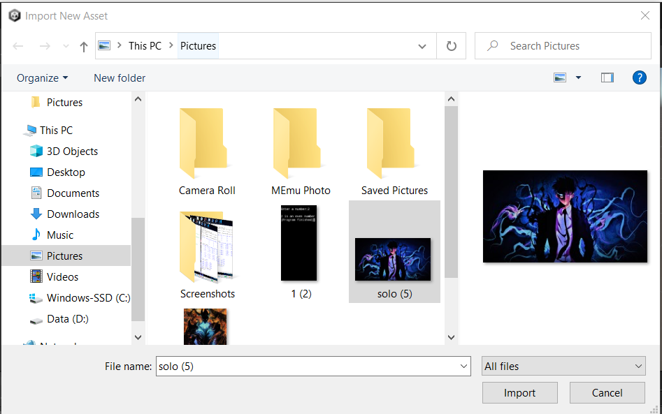

SELECT IMAGE OF ANY KIND

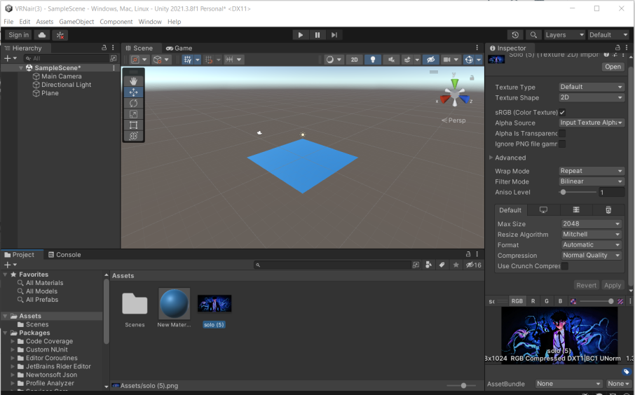

DRAG YOUR IMAGE TO THE PLANE INSIDE

RUN YOUR APPLICATION

